A **virtual machine** is a computer file, typically called an image, that behaves like an actual computer.

In other words, creating a computer within a computer. ...

The **virtual machine** is sandboxed from the rest of the system, meaning that the software inside a **virtual machine** can't escape or tamper with the computer itself.

**Azure Virtual Machine is one of the several types of on-demand , scalable computing resources that Azure offers**

**When you run Azure VM, you pay for the compute time on a per-minute basis**

**The price for VM’s is calculated based on their size, the operating system, and any licenced software installed.**

**To avoid the corresponding charges, whenever you are not using it, you should change its state to Stopped (De allocated)**

**Azure VM Sizing :**

<https://docs.microsoft.com/en-us/azure/virtual-machines/sizes>

**In azure, you select from a range of predefined configuration options that correspond to different VM sizes**

**The VM size determines characterises such as number and speed of its processors, amount of memory, maximum number of network adapters or data disks you can attach to it, and maximum size of temporary disk**

**When you create a VM, We get two disks C: D:**

**To increase size of VM, we add Data Disks**

**Different types of Disks**

<https://docs.microsoft.com/en-us/azure/virtual-machines/windows/disks-types#:~:text=Azure%20ultra%20disks%20deliver%20high,your%20virtual%20machines%20(VM).>

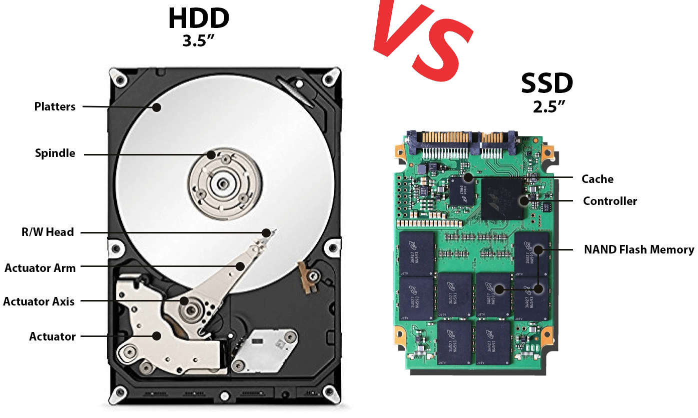

 some obvious advantages about laptop SSD upgade.

* **Faster speed**: SSD disks offer much faster speeds than traditional HDDs. When you upgrade to an SSD you will experience faster boot times and response times when loading your files or folders.
* **Rugged data protection**: SSD disks are much better at protecting your data from accidental damage caused by knocking or dropping the drive. This is because SSDs do not contain any movable parts like traditional HDDs which contain many.

On top of this, SSDs are lighter, quieter, more durable, produce less heat, and consume less power.

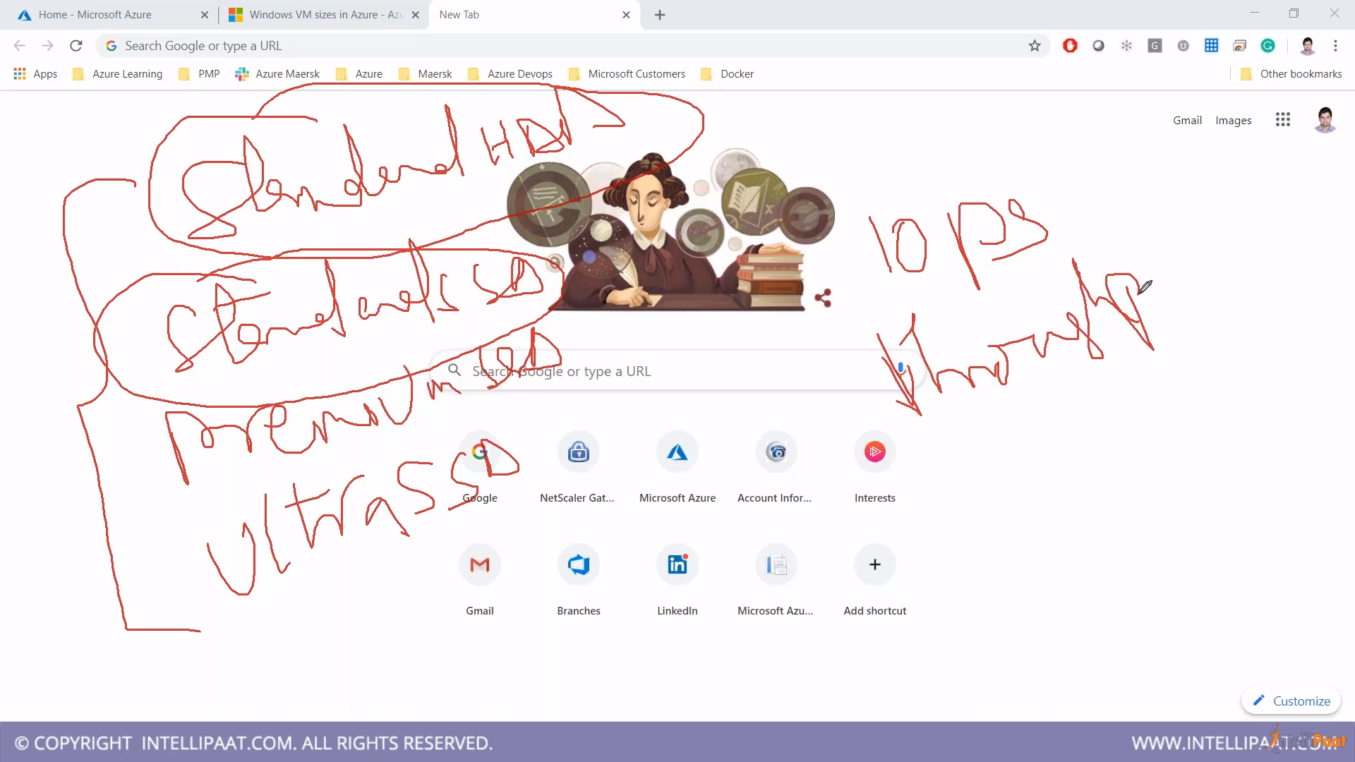

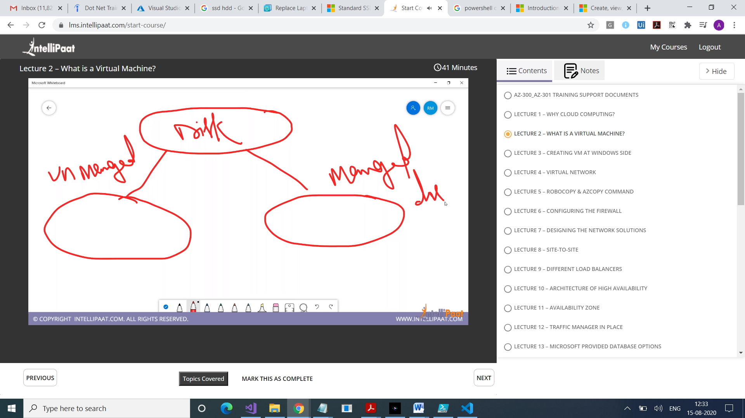

**M in Managed for Microsoft , whole storage related things will be taken care by Microsoft**

**U in Unamanaged for you , storage will be additional here, that you need to take care now**

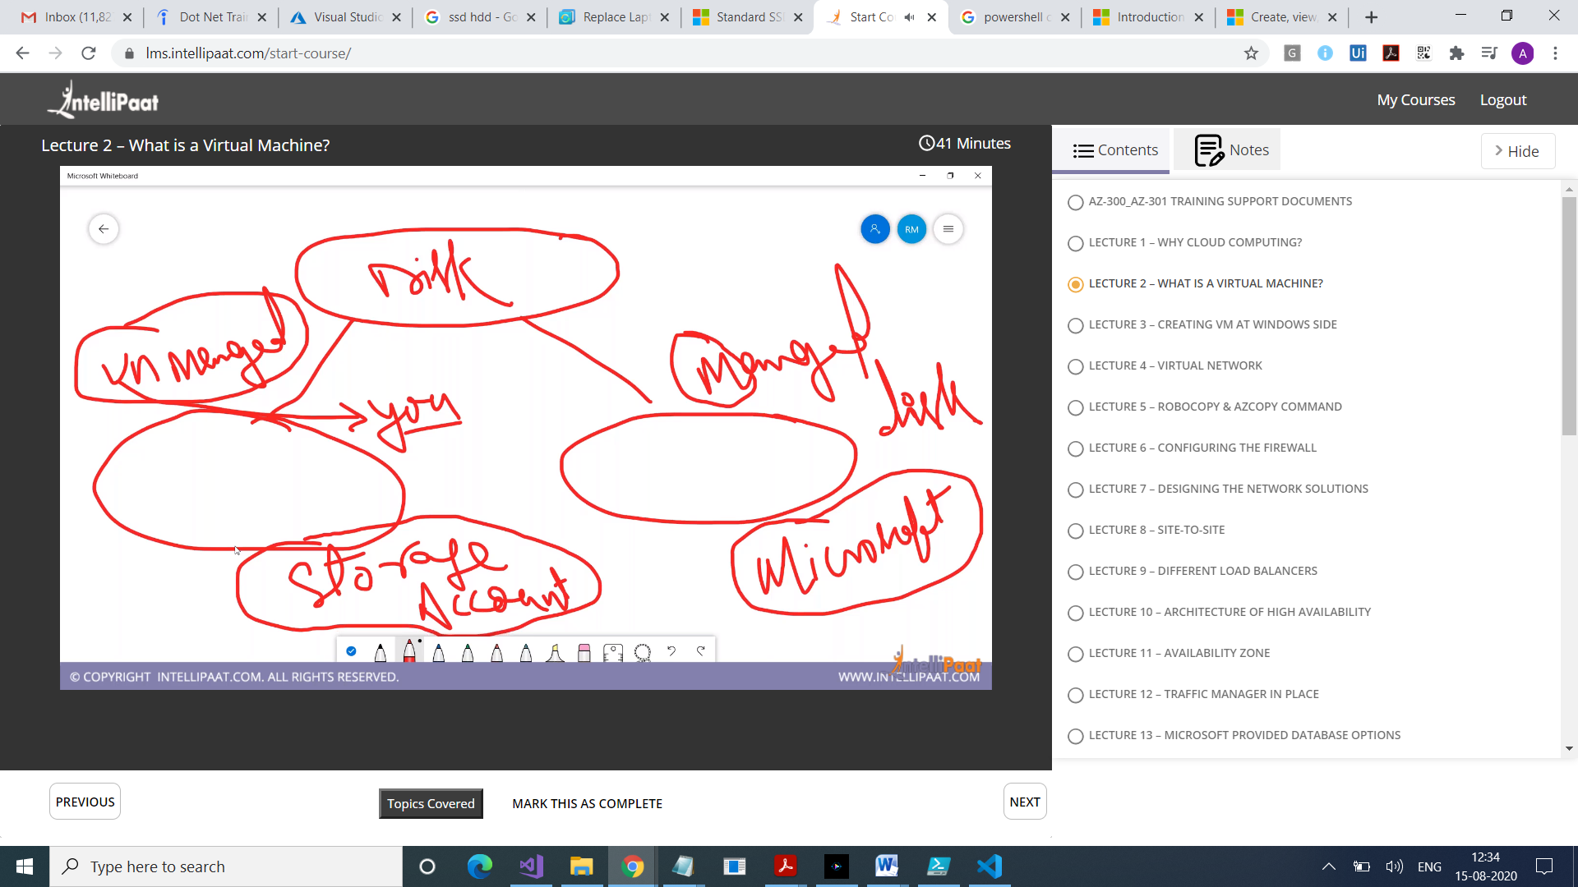

**Disk that you attach to Azure VMs are stored as Virtual Hard Disk(vhd) files within an Azure storage account.**

**Azure disks are designed for 99.999% availability**

**You have three replicas of your data that enables high durability**

**There are two performance tiers for storage that you can choose from**

**Standard Storage : Backed by HDD**

**Premium Storage : Backed by SSD. Delivers high performance, low-latency,**

**Virtual machines** allow you to run an operating system in an app window on your desktop that behaves like a full, separate computer. You can **use** them play around with different operating systems, run software your main operating system can't, and try out apps in a safe, sandboxed environment.

A **virtual machine** is a software **computer** that, like a physical **computer**, runs an operating system and applications. The **virtual machine** is comprised of a set of specification and configuration files and is backed by the physical resources of a **host**.

( **Sandboxing** is a software management strategy that isolates applications from critical system resources and other programs. In computer security, a sandbox is a security mechanism for separating running programs)

**Azure Stack** Hub is a hybrid cloud platform that enables you to use **Azure** services from your company or service provider datacenter. ... **Azure Stack** Hub delivers a subset of the services and features that are available in **Azure**. Your company or service provider can choose which services they want to offer

A **bare metal** environment is a computer system or network in which a virtual machine is installed directly on hardware rather than within the host operating system (OS). The term "**bare metal**" refers to a hard disk, the usual medium on which a computer's OS is installed.